St Albans
Girls’ School

New Members Form JULY 2018
Name:

Telephone No:

Email:

I am willing to help in the following way(s)
please tick box
Sitting on the STAGS PTA Committee (once every half term approximately, plus involvement in running events)
Helping at a future PTA event
Helping out in some other capacity (through your work or personal contacts/skills)

Please state briefly how you can help:

PLEASE RETURN TO SCHOOL IN AN ENVELOPE MARKED “STAGS PTA”
For more information about the PTA please email: pta@stags.herts.sch.uk
Please note that by completing this form you are consenting to the STAGS PTA retaining this information, which will be held securely and only for the use of the STAGS PTA and destroyed once your daughter leaves STAGS.
Many thanks
Helen Buck (Chair of STAGS PTA)

STAGS PTA are compliant with Article 5 of the GDPR:
- The PTA will hold details included on this form in a spreadsheet
- The purpose of holding this data is so that we can contact you about PTA events
- Please contact us if you would like your information removed at any time
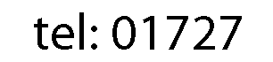
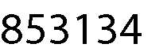
- This form will not be shared outside of PTA or used for any other purpose

